FOR IMMEDIATE RELEASE

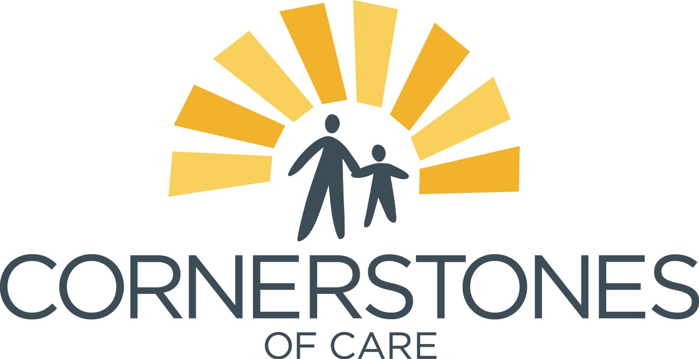

COMMUNITY PARTNERS UNITE FOR A POP-UP FARMERS MARKET AND SUNDAY FUNDAY AT BIER STATION ON MARCH 12
Presented by Goose Island, 100% of proceeds of 312 Urban Wheat and IPA will benefit the young farmers and families at Cornerstones of Care
Kansas City, MO - March 6, 2017 - More than half of the youth served by Cornerstones of Care are living in food insecure households. This means they have limited or uncertain access to food at home. Community partners have united to support the establishment of the healthy living and food systems program at Cornerstones of Care. In partnership with Cultivate KC, Kansas City Community Gardens and Giving Grove, the community-centric program teaches mind, body, community and environmental health.
93% of youth in our day treatment program would like to take fruits and vegetables home.
The Healthy Living and Food Systems program is designed to address the ongoing community need for fresh, healthy produce, while providing educational and entrepreneurial outlets for children and youth who have experienced trauma or mental health challenges.
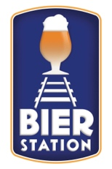
“We have fruit trees, raised beds full of crops, structures that need repairs, insects to catch and study and woods to explore. There is an amazing amount of learning recourses and opportunities right outside our school’s doors. The best part is as the students learn while they are getting exercise, fresh air, and sun. Even better are the exciting pedagogies being developed where students learn through creative play and self-directed subject exploration,” says Theo Bunch, Outdoor Education and Vocational Instructor at Cornerstones of Care.
Bier Station, a critical partner of nonprofit organizations in Kansas City is hosting a community fundraiser and pop-up farmers market to financially support the farmers and families benefiting from the healthy living and food system’s program.
When: March 12, 2017, 1:00pm - 5:00pm
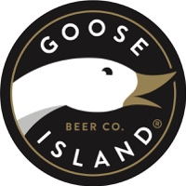
Where: Bier Station
120 E Gregory Blvd, Kansas City, MO 64114
What: Sunday Funday Community Fundraiser & Pop-up Farmers Market presented by Goose Island and hosted by Bier Station - Entry is free!
- 100% of proceeds from Goose Island’s 312 Urban Wheat and IPA, plus 10% of all tap sales will benefit Cornerstones of Care
- Silent auction items: 12 rare bottles of Goose Island’s 2015 Bourbon County Stout and a Goose Island Bourbon County Stout barrel
- Raffle items will also be available

About Cornerstones of Care:
Cornerstones of Care has a long legacy of partnering with children, young adults and families to create safe and healthy communities. Through decades of trauma-informed expertise, Cornerstones of Care effect positive change in the communities it serves, raises awareness and gives a stronger voice to those in need, and deliver a fully-integrated approach to care. For more information, visit cornerstonesofcare.org or talk with us on Facebook, Twitter, or LinkedIn.

